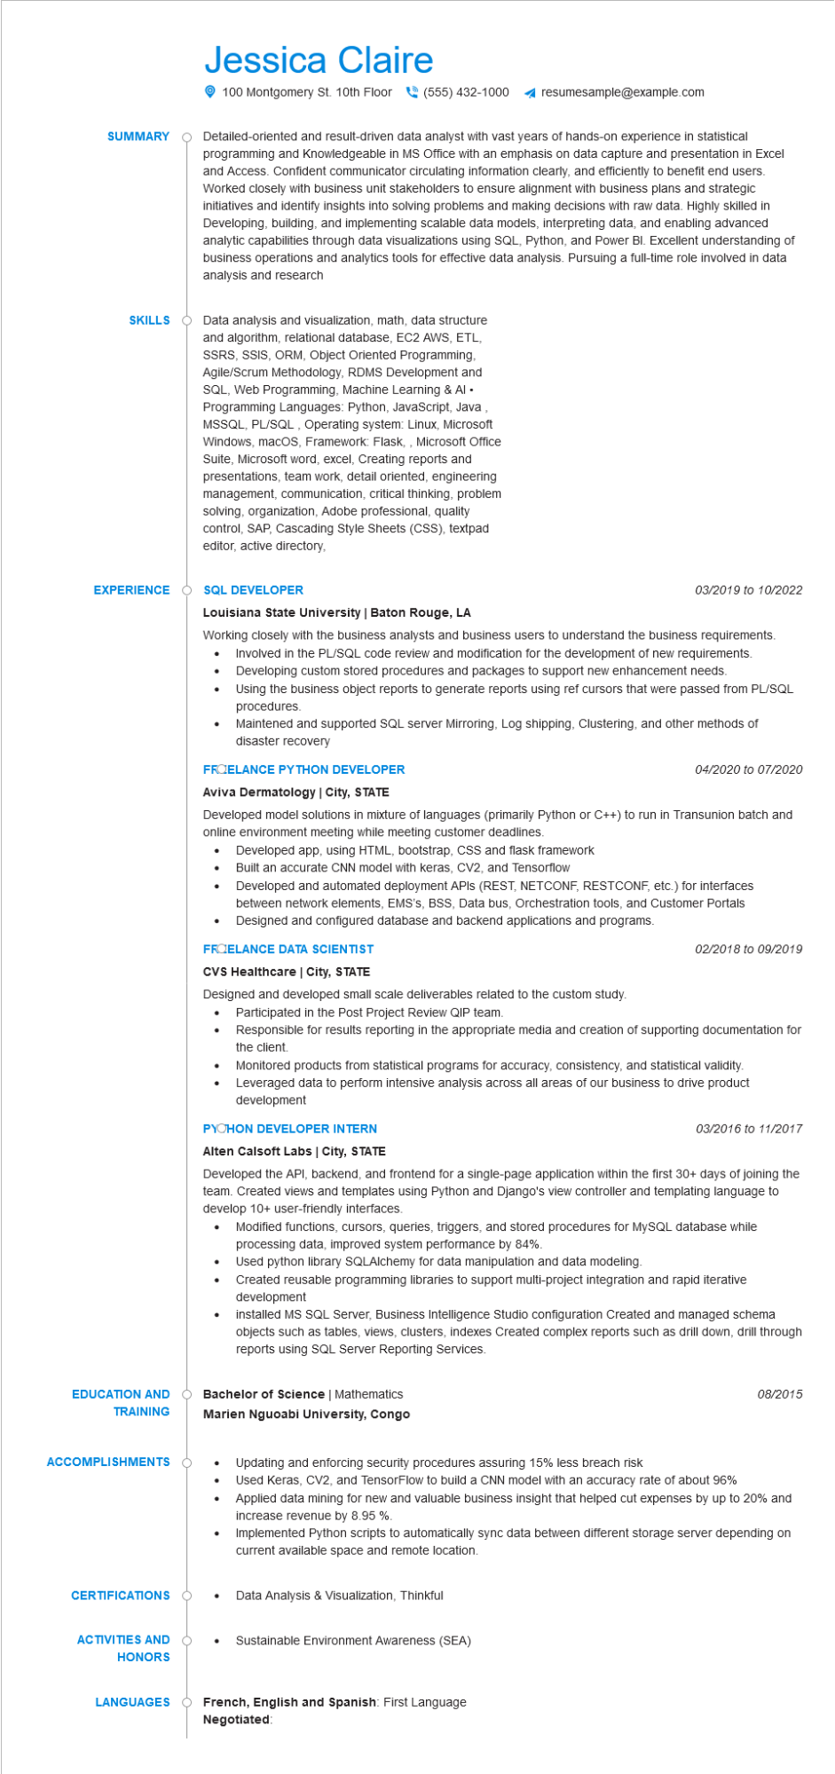
SUMMARY
Jessica Claire
100 Montgomery St. 10th Floor (555) 432-1000 ◄ resumesample@example.com
Detailed-oriented and result-driven data analyst with vast years of hands-on experience in statistical programming and Knowledgeable in MS Office with an emphasis on data capture and presentation in Excel and Access. Confident communicator circulating information clearly, and efficiently to benefit end users. Worked closely with business unit stakeholders to ensure alignment with business plans and strategic initiatives and identify insights into solving problems and making decisions with raw data. Highly skilled in Developing, building, and implementing scalable data models, interpreting data, and enabling advanced analytic capabilities through data visualizations using SQL, Python, and Power BI. Excellent understanding of business operations and analytics tools for effective data analysis. Pursuing a full-time role involved in data analysis and research
SKILLS Data analysis and visualization, math, data structure and algorithm, relational database, EC2 AWS, ETL, SSRS, SSIS, ORM, Object Oriented Programming, Agile/Scrum Methodology, RDMS Development and SQL, Web Programming, Machine Learning & Al⚫ Programming Languages: Python, JavaScript, Java MSSQL, PL/SQL, Operating system: Linux, Microsoft Windows, macOS, Framework: Flask,, Microsoft Office Suite, Microsoft word, excel, Creating reports and presentations, team work, detail oriented, engineering management, communication, critical thinking, problem solving, organization, Adobe professional, quality control, SAP, Cascading Style Sheets (CSS), textpad editor, active directory,
EXPERIENCE O
SQL DEVELOPER
03/2019 to 10/2022
Louisiana State University | Baton Rouge, LA
Working closely with the business analysts and business users to understand the business requirements. • Involved in the PL/SQL code review and modification for the development of new requirements. Developing custom stored procedures and packages to support new enhancement needs.
Using the business object reports to generate reports using ref cursors that were passed from PL/SQL procedures.
Maintened and supported SQL server Mirroring, Log shipping, Clustering, and other methods of disaster recovery
FROELANCE PYTHON DEVELOPER
04/2020 to 07/2020
Aviva Dermatology | City, STATE
Developed model solutions in mixture of languages (primarily Python or C++) to run in Transunion batch and online environment meeting while meeting customer deadlines.
•
Developed app, using HTML, bootstrap, CSS and flask framework
Built an accurate CNN model with keras, CV2, and Tensorflow
•
between network elements, EMS's, BSS, Data bus, Orchestration tools, and Customer Portals
Developed and automated deployment APIs (REST, NETCONF, RESTCONF, etc.) for interfaces
•
Designed and configured database and backend applications and programs.
FROELANCE DATA SCIENTIST
CVS Healthcare | City, STATE
02/2018 to 09/2019
Designed and developed small scale deliverables related to the custom study.
Participated in the Post Project Review QIP team.
Responsible for results reporting in the appropriate media and creation of supporting documentation for the client.
Monitored products from statistical programs for accuracy, consistency, and statistical validity. Leveraged data to perform intensive analysis across all areas of our business to drive product development
PYCHON DEVELOPER INTERN
Alten Calsoft Labs | City, STATE
03/2016 to 11/2017
Developed the API, backend, and frontend for a single-page application within the first 30+ days of joining the team. Created views and templates using Python and Django's view controller and templating language to develop 10+ user-friendly interfaces.
· Modified functions, cursors, queries, triggers, and stored procedures for MySQL database while processing data, improved system performance by 84%.
Used python library SQLAlchemy for data manipulation and data modeling.
•
Created reusable programming libraries to support multi-project integration and rapid iterative development
•
installed MS SQL Server, Business Intelligence Studio configuration Created and managed schema objects such as tables, views, clusters, indexes Created complex reports such as drill down, drill through reports using SQL Server Reporting Services.
EDUCATION AND O TRAINING
Bachelor of Science | Mathematics
Marien Nguoabi University, Congo
ACCOMPLISHMENTS
08/2015
Updating and enforcing security procedures assuring 15% less breach risk
Used Keras, CV2, and TensorFlow to build a CNN model with an accuracy rate of about 96% Applied data mining for new and valuable business insight that helped cut expenses by up to 20% and increase revenue by 8.95 %.
Implemented Python scripts to automatically sync data between different storage server depending on current available space and remote location.
CERTIFICATIONS
Data Analysis & Visualization, Thinkful
ACTIVITIES AND
Sustainable Environment Awareness (SEA)
HONORS
LANGUAGES
French, English and Spanish: First Language Negotiated:

